

CURRENCY TRADING NEWS ALERT SYSTEM Final REPORT

Word Count: ()

Higher Diploma in Science in Computing

Gordon Leary

# Contents

Contents 1

Abstract 2

Acknowledgements 2

1. Introduction 2

Aim 2

Approach 2

2. Background 2

3. Specification & Design 3

Tools & technologies used 3

Project Scope and Objectives 3

Design Approach 3

Data 4

4. Implementation 4

5. Project Testing and Results 4

6. Conclusions and Future Work 5

7. Demonstration of Progress 5

Status in terms of proposed goals and project plan 5

Milestones Achieved 5

Revised Milestones to be achieved – ‘to do’ list 6

8. Future Work 7

9. References / Bibliography 8

10. Appendices 9

Appendix 1 – Design specification 9

Activities and Menus 9

Schema for Currency Alert System Database 10

Class Diagram 10

Appendix 2 – Sample XML code 11

# Abstract

# Acknowledgements

I would like to take this opportunity to thank my supervisor Harnik Dhoot for his ongoing support during the development of this project. He has been very helpful, insightful and generous with his time and I have learnt a great deal from working with him.

# Introduction

## Aim

To develop a mobile phone application that will alert a trader in the currency market of upcoming fundamental news announcements. The user will be able to download an xml file of all these news release times from a 3rd party broker website and filter these by currency and market impact, save selected events to a watch list, and be alerted by alarm and notification on their android device when such an announcement is imminent. The user will also have the facility to set ‘personal’ alerts.

## Approach

I am using an ‘MoSCoW’, Agile type approach to development due to its fixed deadline. Aiming to keep the scope of the project small and tight, working towards my goals and objectives, expanding on these, time permitting, from a list of options in the future work section.

I am doing regular backups and commits of all code and documents to GitHub. I am also doing a lot of research on Xamarin development, utilising various tutorials including those available on Microsoft’s MSDN channel.

# Background

Currency traders take positions in the market with a view to making a profit by buying a currency pair at a given price and then later selling it at a higher price, the reverse, ‘shorting’, is also possible.

Each week economic data is announced at specific, scheduled times. Most dealing brokerages publicise the times of these news events at the beginning of each week, and then the results as they are released.

These news announcements have the potential to move the market significantly against the position held by traders, causing larger than expected losses. Many shorter-term traders stay out of the market completely at these times, deliberately avoiding any possible negative volatility.

Although there are many tools to automate the trading process, many short-term traders who open and close multiples trades in the same day, often do so manually, keeping note of any news announcements and exiting their trades beforehand.

# Specification & Design

All specification & design diagram are in appendix 1.

## Tools & technologies used

* Xamarin.Android
* Visual Studio 2017 (for development & unit testing)
* C#
* LINQ to XML
* SQLite-PCL
* GitHub
* www.Draw.IO & www.dbdesigner.net(for diagrams)

## 

## Project Scope and Objectives

Minimum Viable Product:

* To download a list of all available scheduled news events for the current week from a third-party website (sample xml file included in appendix 2).
* To be able to sort this list by both currency and expected impact on the market.
* To let the user, select items of interest from the above and store them in a watch list.
* To set alarms and notifications on the user’s mobile device based on their watch list, to alert them of an imminent news announcement release.
* User can add personal alerts to the watch list to be alerted at times not in the XML schedule.
* User can select amount of time to be notified before the news announcement, e.g. 10 or 15 minutes before the news release.

## Design Approach

I developed a basic prototype which has helped to clarify design decisions and gain insight into how a potential user might use the application.

I have also developed several small ‘proof of concept’ apps, which I have then integrated into the main project, including;

* + Phone ringing and vibrating.
  + Alarm manager – to wake up an activity at a future point in time.
  + XML to LINQ – to consume and filter data from XML file.
  + Toolbars – to use multiple toolbars on same activity using ‘appcompat’ for backward compatibility.

## ~~Data~~

~~I plan to use a persistent data layer using SQLite-PCL, schema outlined below. The application will load existing data upon start-up. Any additions to the user’s alert list will be written immediately to the database, so as in the event of an unexpected shut down data will already be saved, e.g. device runs out of battery power. URL for downloading xml data file will also be stored in the database, thus providing a location for multiple URLs if required in future development.~~

~~As data is only relevant for the current week, all data will be purged, including database, when the user downloads the next xml file of weekly news announcements, published every Sunday night.~~

**Data Access:**

Currently every time any data is required, a call to the database is carried out. There is no central repository cached in memory. This is because the amount of data is very small, 50 to 60 items of market data per week, discarded weekly, and because SQLite is essentially reading and writing to a text file, performance has not been issue.

The class DataAccessHelpers contains static methods that can be used throughout the entire application to perform the required data manipulation.

In future development, if performance did indeed become an issue, a ‘Singleton’ type pattern could be implemented. This would create a central repository, e.g. ‘DataStore’ which would retrieve data from the database and cache it in memory, where it could be manipulated by all classes as required.

Using the ‘Singleton’ pattern would ensure that only one instance of the repository would be created, avoiding any duplication issues. The data would then be written back to the database upon the exit of the application.

# Implementation

**Development process:**

**Graphic Elements**

An important aspect of any mobile application is its visual aesthetic. If the UI elements are visually pleasing, this will make it easier for the user to interact effectively with the app and enhances the overall user experience.

For the splash screen I created my own design using the windows 10 program ‘Paint 3D’.

For the currency flags that are used in the scrollable views I used icons from:

<https://www.flaticon.com/packs/international-flags>

While appropriate, these were in the wrong size and had issues with transparency that caused noticeable, irregular border lines. Android Asset Studio was a great help in fixing all the above.

<https://romannurik.github.io/AndroidAssetStudio/>

It also provided different screen density versions of each image, these are stored in the Resources folders: ‘mipmap-hdpi’ to ‘mipmap-xxxhdpi’. These means that if application is run on devices of different sizes the appropriate sized graphic will be displayed, avoiding issues such as pixilation, when a small graphic is enlarged too much.

I used a colour tool to find complementary colours, and different shades of the same colour:

<https://www.colorhexa.com/0070bf>

And used the android code in the button_state.xml file to set corners, colour gradients and to call other xml to change button colour, when a button was pressed, e.g.

android:state_pressed="true"

**Regularly re-installing the application.**

Usually when I would run the application, using Visual Studio, I would either run it in debug mode, or run without debugging. Regardless of whether I was deploying to the emulator or to a real phone the app would avail of whatever data was still available from a previous deploy. Eventually there was no virtual memory left on the emulator which forced the deleting of unwanted apps and a clean install of the app. This exposed several hidden issues, including a crash that was caused by a call to the database before the appropriate tables were ready to be accessed.

E.g. method:

GetAllNewsObjectDataFromDatabase()

which is called to get all the required data from the database, and then passed to ReCycle Adapter to be displayed on the screen.

Going forward part of my development process was to;

* Uninstall the app regularly, to be able to test in a clean, blank environment.
* Ensure the appropriate checks are in place, e.g. checking that a table exists before calling a method that tries to read or write to it.

**Geographic and location issues:**

Currency trading is a global activity and the website that provides the XML file of weekly market news events, ForexFactory.com is an American site. To simplify zone type issues, they release their XML in GMT, Greenwich Mean Time.

During DST, daylight savings time, we are one hour ahead of GMT time.

In method:

ConvertXmlAndStoreInDatabase of DataStore.cs

I check to see if the application is currently in DST using:

DateTime.IsDaylightSavingTime Method ()

If it is, then an hour is added to the xml data as it is stored in the database to bring it in line with DST. When not in DST nothing is added, so the time simply remains the same. This only applies to market events and alerts and does not apply to personal alerts set by the user.

Currently the application would only be suitable for countries that are in the same time zone as Ireland and the UK, and that follow DST. In future development a facility could be added to update the market alert times to be correct for whatever time zone the device running the application is in.

**Device language setting:**

Another issue that presented itself very unexpectedly was that of which version of English the host device is set to. During development I have been testing the app on both my own phone, Samsung S7 (Oreo) and the emulator (Nougat). Unknowingly the Samsung had its language set to English (Ireland) while the emulator was set to English (American).

A method that used I used in ConvertString_s_ToDateTimeObject:

DateTime.Parse(dateAndTimeString)

to convert a string to a date-time object, caused the app to app to fail on the Samsung phone, a difficult problem that took some time to locate and solve, and was eventually fixed by creating a CultureInfo object:

DateTime.Parse(dateAndTimeString, new CultureInfo("en-US"));

**Threading:**

I implemented threading in the following methods in UserAlertsActivity;

* SetAlarm
* DeleteAlarm

These methods both use the AlarmManager class to set and delete alarms. It was possible for me to implement these on separate threads as the application didn’t need to wait for any returned response before continuing. If they remained on the UI thread, the UI would freeze until they had completed their work. Also, the debug console window was warning that there were too many processes running on the UI thread.

I also tried to implement threading in the ‘Update XML’ option (Main screen, top menu, 1st option). When the user selects this option, the application downloads an XML file from the ForexFactory.com brokerage site. During the download, the UI temporarily freezes, preventing any other user interaction with the application. I experimented with putting this process onto a separate thread, which did prevent the UI from freezing during the download, but it caused other issues downstream because I hadn’t designed the application with threading in mind from the outset, e.g. methods were getting called before the required data that was returned by the download thread was available, causing timing issues in terms of updating the screen display and database access

In any future development I would like to implement threading throughout the application. While threading would bring performance benefits it would require some considerable change to the architecture of the application to avoid race conditions etc.

# Project Testing and Results

~~As outlined in my objectives, my initial priorities have been to develop a prototype to decide upon the user interface, and to develop several, small proof of concept applications to learn and get a greater understanding of the technologies I’ll be implementing in the project. With these milestones achieved I will now integrate testing into my development as follows;~~

* ~~Manual testing for UI elements (collect data & manually enter into Excel spreadsheet).~~
* ~~Unit tests for non-UI code, e.g. filtering of xml data in the view all currency events section.~~

~~I would prefer to be using test driven development, TDD, but would need to implement the system using an MVC or MVVC type pattern to achieve this, beyond the current scope of this project, but this has been included as a possible consideration for future work.~~

**Testing:**

The importance of testing in the development of any system or application cannot be overstated. With a variety of testing methodologies to choose from I decided to implement a manual testing process for several reasons.

In our advanced programming module, we had exposure to TTD, test driven development and the work of ‘Uncle Bob’, Robert Martin. In time, and with a more experienced skill set, TTD is something I would aspire to, writing your tests before your code seems to be a very progressive way to approach development.

We also had exposure to Unit Testing, a methodology which should be employed by all developers, regardless of whatever other testing methods are being utilised at higher levels within their team or organisation. This requires that your code be developed in such a way as to facilitate such testing.

In my application I have endeavoured to write my code to enable unit testing, where possible writing my methods and functions so that they return a value such as a true or false bool, or an int containing the number of rows updated in the database etc. I have also ‘wired up’ a unit test project within Visual Studio, with some dummy tests.

A large percentage of my application uses technologies that I’ve researched myself, e.g. utilising Android’s date and time pickers, phone notifications etc. As result, it has been impractical to write tests, or adapt my code ahead of time for such features. I would though, regard this as a priority for any future development.

**Manual Testing:**

During development, anytime I would introduce a new feature, e.g. adding an extra item to a menu, I would go through a process of not only trying out the new feature, but also verifying that all the previously working features still worked as expected. Choosing manual testing, in the end, was a process of documenting my natural, personal development style.

I researched a lot of tutorials on YouTube, where different tutors presented how they laid out their manual tests in an Excel format, and took that as a basis for my own Excel based, manual test layout.

**Testing on multiple devices:**

For future development of an application that is aiming to be released commercially it would be desirable to test the app on as many different devices as possible, to access both functional performance and visual aesthetics. While it is possible to run many different emulators in Visual Studio, a time-consuming task, a commercial option such as Microsoft’s own ‘Visual Studio App Centre’ which includes Xamarin Test Cloud, (appcenter.ms) would be helpful. This lets the developer test their app ‘in a hosted device lab with 1000s of real iOS and Android devices. You’ll receive test results, full-resolution screenshots of every step, along with performance metrics’.

**Automated UI Acceptance Tests:**

Another invaluable option for testing in future development would be the use of Xamarin.UITest. This allows the automation of UI acceptance tests and can be used within Visual Studio. Its most impressive feature is that in can simulate a user interacting with all the user interface components such as button presses, swipes, gestures etc., providing a very thorough and robust testing environment.

Please note, manual test cases are included in an accompanying Excel file.

**Known issues:**

If a user alert is set on market data whose date-time has already passed, then the alert fires instantly.

* A check needs to be added to only allow the user to set alerts on future market events.

Multiple alerts are allowed for the same date-time.

The ‘Update Market Data’ (Main Activity top menu, option 1) hangs if there is a problem with the host device’s wifi or internet connection. An option would be to have a timeout type function surrounding the xml download, and to use test data already in the Assets folder until downloading is possible again.

# Conclusions and Future Work

# Demonstration of Progress

* Log of all work done to date (accompanying text file).
* Main Application (Visual Studio – zip file)
* Proof of Concept Apps (Visual Studio – zip file)

## Status in terms of proposed goals and project plan

I feel that I am making timely progress in the development of my application. Milestones 1 to 5 detailed below have been achieved. Following an Agile-type methodology, producing a prototype on which to base further development, has helped to clarify my approach, especially the layout and design of the app.

I have completed an extra ‘Xamarin.Android’ course on Udemey.com and worked through several tutorials on Microsoft’s developer network, which has given me more options in terms of screen real-estate management, menus, toolbars etc.

* Using ‘AppCompat’ toolbar, for backwards compatibility with older mobile devices, also allowing me to have two toolbars on each activity screen, a global navigation menu, and a context driven one.
* Alert notification manager for alerts based on Item-Click events in a list of data.
* Changing button-state (on-Click color using xml).

## Milestones Achieved

1. Small proof of concept app – to demonstrate a working example of calling an alarm or notification at a pre-scheduled time, e.g. setting mobile phone to ring, vibrate and display an on-screen message at a set time.
2. Console app to demonstrate retrieval and manipulation of the 3rd party XML news event list, e.g. convert XML data to list & sort by currency, date or impact.
3. A non-functional mock-up / prototype to;
   1. display design and flow of app from one screen to another,
   2. use of menus, graphics and theme templates,
   3. hard-coded sample data.
4. Prototype produced with basic functionality.
5. Wire-up Date-Picker & Time-Picker ‘proof of concept’ app into Personal Alerts.

## Revised Milestones to be achieved – ‘to do’ list

* List of Personal alerts (watch-list):

Display WatchList

Add Personal Alert

Edit / Delete Personal Alert

* Download xml file from ForexFactory.com, i.e. replace current hard coded sample data.
* Display all data (formatted)
* Sorting data:
* By currency – e.g. Yen, Dollar, CAD, GBP (need currency icons)
* By impact – high, medium, low
* By both, in any combination – checkbox menu
* Add onItemClick() event to currency announcements – to add alert to an item (add it to watch list)
* SQL-PCL:
  + - Research 🡪 Proof of concept app 🡪Integrate into app.
    - On app start, in SpashActivity -Load data from SQL-PCL database.
    - On app close, write out, save, data to SQL-PCL database.
* Theme & UI polishing / refinement
  + - Test on different emulated phones (set up other emulators on my development machine).

# Future Work

Below are listed items for possible future development which I believe would be valuable additions to the application time permitting.

Listed in order of preference;

* ~~Localization.~~
  + ~~Converting the app to another language, e.g. French, would mean that all strings and text are in separate xml files, ensuring better design and separation of concerns, making it easier to translate the application to other languages and possibly gaining more potential users in other territories.~~
* ~~Utilizing the ‘ReCycler’ view:~~
  + ~~Not required yet, due to the small amounts of data in each list, but this would enhance the performance of the app if the size of data was to grow.~~
* ~~Automatically add new data sources and verify their content:~~
  + ~~The app relies on one data source, ForexFactory.com for its XML data (news announcement schedule). While this is a reliable and well-established resource some redundancy would be desirable. A web service could be developed and deployed to Azure. The app could call an API to enable downloading from multiple sources and to verify that their content is current.~~
* ~~Import, export .csv file of ‘watch-list’ events.~~
* ~~Landscape and portrait modes for different devices.~~
* ~~Integrate application with Google Calendar.~~
* ~~Tracker facility for the user to be able to keep a record of their market trades & forward reports to a selected email.~~
* ~~Convert application to a Model, View, Controller (MVC), or Model View, View Model (MVVP) type structure, to have greater separation of concerns and to enable more comprehensive testing of the application.~~
* Export watch-list to csv file – also have an import csv option.
* Integrate with Google calendar (API ?) – flag user time scheduling conflicts.
* Schema for ‘forex-factory’ xml download – program to this (?).

# References / Bibliography

Deitel, Deital, 2014. *Visual C# 2012 How to Program* 5th ed.  H. Marcia et al., eds., Harlow: Pearson Education.

Leibowitz, M., 2015. *Xamarin Mobile Development for Android Cookbook* 1st ed. A. Banerjee et al, eds. Birmingham: Packt Publishing Ltd.

Albahari, Albahari, 2016. *C# 6.0 Pocket Reference* 1st ed. B MacDonald et al., eds., California: O’Reilly Media Inc.

Sommerville, I., 2015. *Software Engineering* 10th ed. H. Marcia et al., eds., Harlow: Pearson Education.

Murphy, Mark L., 2018. *The Busy Coder's Guide to Android Development* 8.10th ed. Commons Ware

Xamarin University. Available at: <https://university.xamarin.com> [Accessed May 2018].

Xamarin Android Tutorials by Joe Rock. Available at: <https://www.youtube.com/channel/UCFH-Tn6ggt9yLWJ4V9NizZA> [Accessed May 2018].

C# Training Tutorials. Available at :<https://www.youtube.com/user/IAmTimCorey> [Accessed May 2018].

Xamarin Documentation: Available at: <https://docs.microsoft.com/en-us/xamarin/#pivot=platforms&panel=Android> [Accessed May 2018].

Xamarin Android Udemy Course by Grant Klimartys. Available at: <https://www.udemy.com/xamarin-android-a-master-guide-to-mobile-app-development/learn/v4/overview> [Accessed May-June 2018]

# Appendices

## Appendix 1 – Design specification

### Activities and Menus

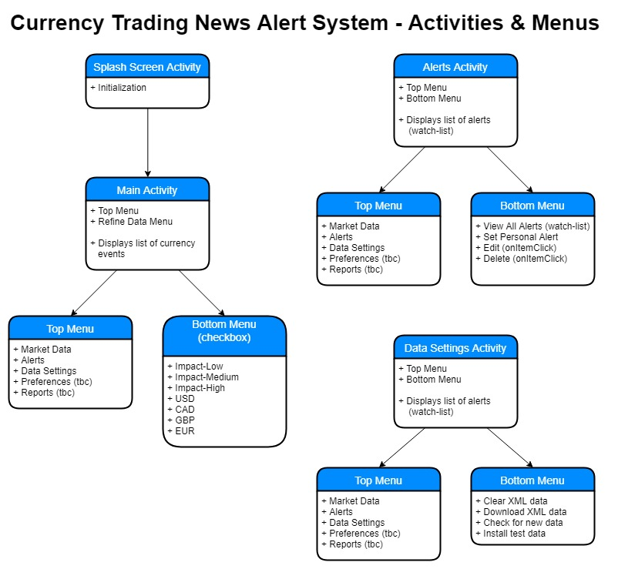

### Schema for Currency Alert System Database

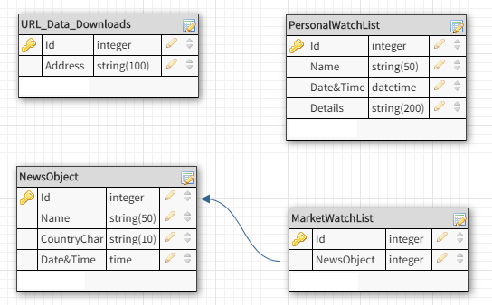

### Class Diagram

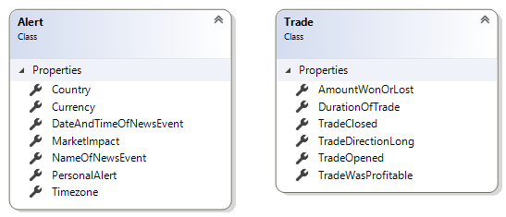

Nb. Trade class is only for use in future possible development.

## Appendix 2 – Sample XML code

Sample XML of fundamental news releases published weekly. Available at: https://www.forexfactory.com/ffcal_week_this.xml

<?xml version="1.0" encoding="windows-1252"?>

<weeklyevents>

<event>

<title>FPI m/m</title>

<country>NZD</country>

<date><![CDATA[04-15-2018]]></date>

<time><![CDATA[10:45pm]]></time>

<impact><![CDATA[Low]]></impact>

<forecast />

<previous><![CDATA[-0.5%]]></previous>

</event>

<event>

<title>Rightmove HPI m/m</title>

<country>GBP</country>

<date><![CDATA[04-15-2018]]></date>

<time><![CDATA[11:01pm]]></time>

<impact><![CDATA[Low]]></impact>

<forecast />

<previous><![CDATA[1.5%]]></previous>

</event>

<event>

<title>WPI m/m</title>

<country>EUR</country>

<date><![CDATA[04-16-2018]]></date>

<time><![CDATA[5:52am]]></time>

<impact><![CDATA[Low]]></impact>

<forecast><![CDATA[0.4%]]></forecast>

<previous><![CDATA[-0.3%]]></previous>

</event>

</weeklyevents>